
2

The toolkit templates
Social Impact Toolkit
National Programmes
The toolkit templates
 | Session register
 | Guidance for  observational evaluation | - For an online session  - For an in-person session
 | Questionnaire | - For adults  - For children  - For a new audience  - For projects with  long term engagement

Session Register

Tally each visitor in appropriate column
Visit info | First  visit | Attended  before | Additional comments  If visited before, have previous sessions inspired any cultural engagement e.g. visiting another museum, reading further on topic, attending a similar session elsewhere, having a conversation afterwards.

Date
Number of people

Date
Number of people

Date
Number of people

Date
Number of people

Date
Number of people

Observation Sheet for Online Sessions
Learning and Engaging | Mark down any  instance below | Health and wellbeing | Mark down any  instance below

Discussion |  | Smiling
Asking questions |  | Surprise, Shaking  head, “wow”
Sharing own experiences |  | Learning forward  (showing interest)
Conversation/interaction between participants |  | Nodding
Participation in quiz/activity |  | Laughing
Note
Observation Sheet for In-Person Sessions
Learning and Engaging | Mark down any  instance below | Health and wellbeing | Mark down any  instance below

Discussion |  | Smiling
Asking questions |  | Laughing
Sharing own experiences |  | Making social connections with other participants
Touching objects |  | Making emotional connections with objects, appreciating aesthetics
Notes:
We’d love to hear what you thought about your visit today.
How often have you visited the museum?
 | This is my first visit |  | It’s been a long time since I’ve visited
 | I’ve been a few times |  | I visit a few times a year |  | I visit here often
Today at the Museum…
Please circle your response to each statement
I enjoyed this experience. | Strongly agree | Somewhat agree | Neither agree nor disagree | Somewhat disagree | Strongly disagree
I learned something new about the museum and its collections. | Strongly agree | Somewhat agree | Neither agree nor disagree | Somewhat disagree | Strongly disagree
This experience prompted me to think differently about something. | Strongly agree | Somewhat agree | Neither agree nor disagree | Somewhat disagree | Strongly disagree
I am curious to know more about this topic | Strongly agree | Somewhat agree | Neither agree nor disagree | Somewhat disagree | Strongly disagree
I would like to bring my family/friends back to the museum | Strongly agree | Somewhat agree | Neither agree nor disagree | Somewhat disagree | Strongly disagree
Circle the words that describe your feelings about your experience today:
surprised |  | jittery |  | cheerful |  | nervous |  |  | optimistic
proud |  | wonderful |  | calm |  | bored | afraid |  |  | sad
 | angry |  | tired |  |  | confident |  | engaged |  | relaxed
worried |  | great |  | refreshed |  | happy |  |  |  | anxious
excited |  |  |  | disappointed |  |  |  |  |  | confused
 | Or write your  own words: |  | _______________________
_______________________ |  |  |  |  | _______________________
Adult Questionnaire
What did you enjoy most about today?
What would you improve?
Following this session, do you think you will…

Think more about the topic of this session. | Yes | Maybe | No
Share what I’ve learned with someone else. | Yes | Maybe | No
Find out more about the topic online. | Yes | Maybe | No
Attend future sessions like this one. | Yes | Maybe | No

Thank you very much for your feedback.

We hope to see you here at the museum again soon.
Adult Questionnaire

Today at the museum…
I had fun. | 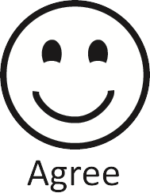 | 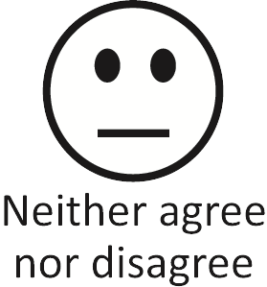 | 
I felt happy.
I learned something new.
I would like to come again.

My favourite part was….

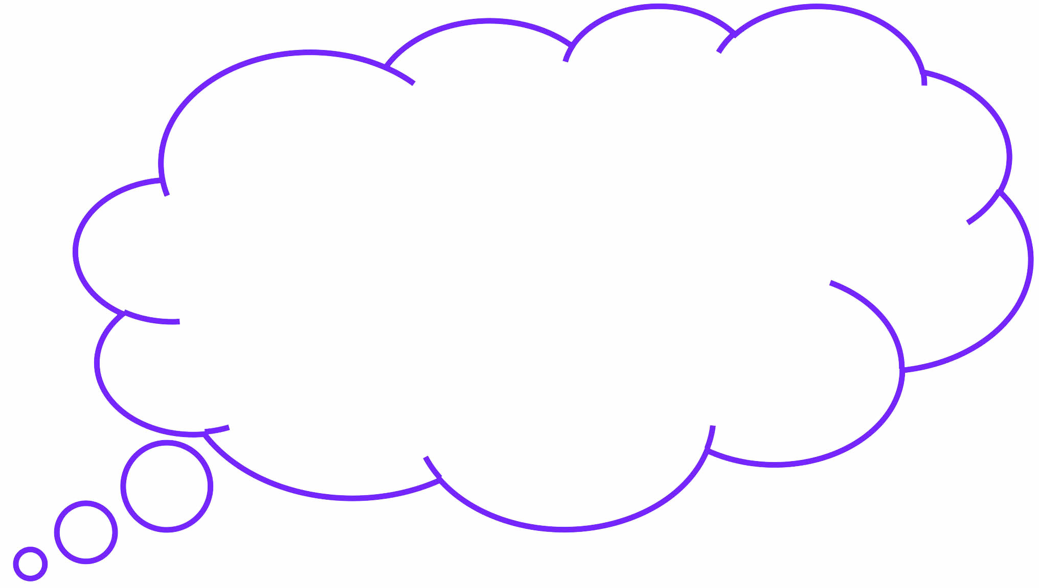
Child Questionnaire
We’d love your feedback on your visit today.
Please circle your response to each statement.
Today at the museum,  I felt welcomed. | Strongly agree | Somewhat agree | Neither agree nor disagree | Somewhat disagree | Strongly disagree
I learned or tried something  new today. | Strongly agree | Somewhat agree | Neither agree nor disagree | Somewhat disagree | Strongly disagree
I was surprised by  what the museum had to offer. | Strongly agree | Somewhat agree | Neither agree nor disagree | Somewhat disagree | Strongly disagree
I feel comfortable returning to  the museum in the future. | Strongly agree | Somewhat agree | Neither agree nor disagree | Somewhat disagree | Strongly disagree
I would like to bring my family/  friends back with me to the Museum | Strongly agree | Somewhat agree | Neither agree nor disagree | Somewhat disagree | Strongly disagree
What three words would you use to describe your visit today?
 |  | _______________________
_______________________ |  |  | _______________________
What could we do to encourage you to come back?
New Audience Questionnaire
We’d love your feedback on our _____________ programme, including your thoughts on what you liked, and how we can improve in the future.
How many sessions have you previously attended?
 | This is my first visit |  | 1 or 2 sessions |  | 3 or 4 sessions |  | 5 or more sessions
Please circle your response to each statement
I have enjoyed participating  in this programme. | Strongly agree | Somewhat agree | Neither agree nor disagree | Somewhat disagree | Strongly disagree
I learned something from this experience I wouldn’t have otherwise. | Strongly agree | Somewhat agree | Neither agree nor disagree | Somewhat disagree | Strongly disagree
I will use something I learned in  my everyday life. | Strongly agree | Somewhat agree | Neither agree nor disagree | Somewhat disagree | Strongly disagree
The Museum is a place that  awakens my curiosity | Strongly agree | Somewhat agree | Neither agree nor disagree | Somewhat disagree | Strongly disagree
I like spending time at the museum | Strongly agree | Somewhat agree | Neither agree nor disagree | Somewhat disagree | Strongly disagree
Circle the words that describe your feelings about your experience today:
surprised |  | jittery |  | cheerful |  | nervous |  |  | optimistic
proud |  | wonderful |  | calm |  | bored | afraid |  |  | sad
 | angry |  | tired |  |  | confident |  | engaged |  | relaxed
worried |  | great |  | refreshed |  | happy |  |  |  | anxious
excited |  |  |  | disappointed |  |  |  |  |  | confused
 | Or write your  own words: |  | _______________________
_______________________ |  |  |  |  | _______________________
Long Term Project Questionnaire
What have been the best parts about this programme?
If you could change one thing, what would it be?
Following these sessions, have you…
Thought more about the topics. | Yes | Maybe | No
Share what you’ve learned with someone else. | Yes | Maybe | No
Investigated more about the topic online. | Yes | Maybe | No
Visited the museum with friends or family. | Yes | Maybe | No

Would you like to participate in a programme like this one again in the future?
 | Yes |  | Maybe |  | No

Long Term Project Questionnaire

